Hunter Black - 113229605

Homework 4: 4.1, 4.5, 4.13

Pg(s). 209 - 213

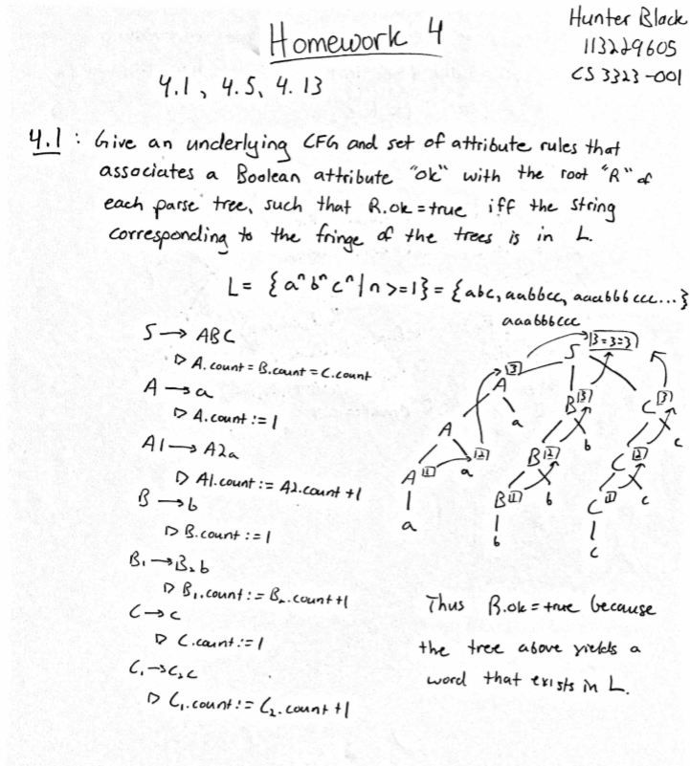

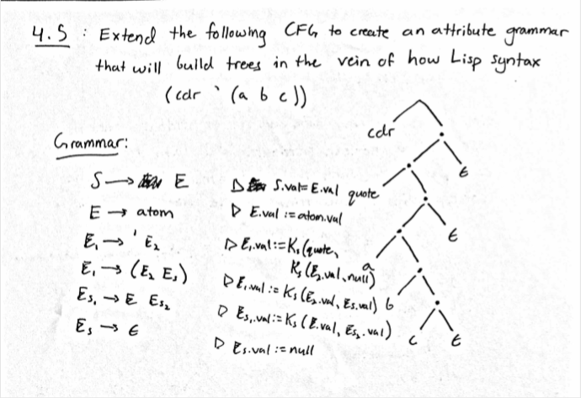

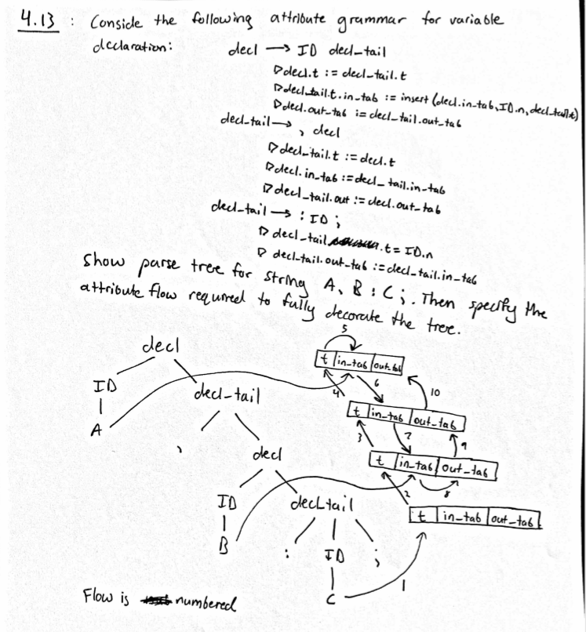

I had to put scans of my work into this word document for Canvas to allow me to submit it. Also I had to write this because you have to have a minimum of 20 words per submission.